# PHARMACY MANAGEMENT SYSTEM

## **1-) WHAT IS PHARMACY MANAGEMENT SYSTEM?**

pharmacy management system is a software system used to manage and organize the day-to-day operations of a pharmacy. This includes tasks such as maintaining medicines, processing prescriptions, managing patient records, and generating reports and create delete update these kinds of things. These systems can also integrate with electronic medical records systems and provide support for insurance claims processing.

## **2-) THE GOAL OF PHARMACY MANAGEMENT SYSTEMS**

* To improve the efficiency and accuracy of the pharmacy's operations, by automating and streamlining tasks such as inventory management, prescription processing, and patient record management.
* by integrating with electronic medical records systems, a pharmacy management system can provide a more comprehensive view of a patient's medication history
* enabling more effective medication management.
* reducing the risk of adverse drug interactions.
* the goal of pharmacy management systems is to improve patient outcomes, increase productivity and reduce the costs of running a pharmacy.

## **3-) BENEFİTS OF PHARMACY MANAGEMENT SYSTEMS**

* increase productivity
* improve patient outcomes
* reduce the costs of running a pharmacy
* Managing of the medicines easily
* Managing of the prescription
* Keeping patients' employee information, prescription records, supplier, and Medicines information in computer environment

## **4-) ENTITY RRELATIONSHIP DIAGRAM**

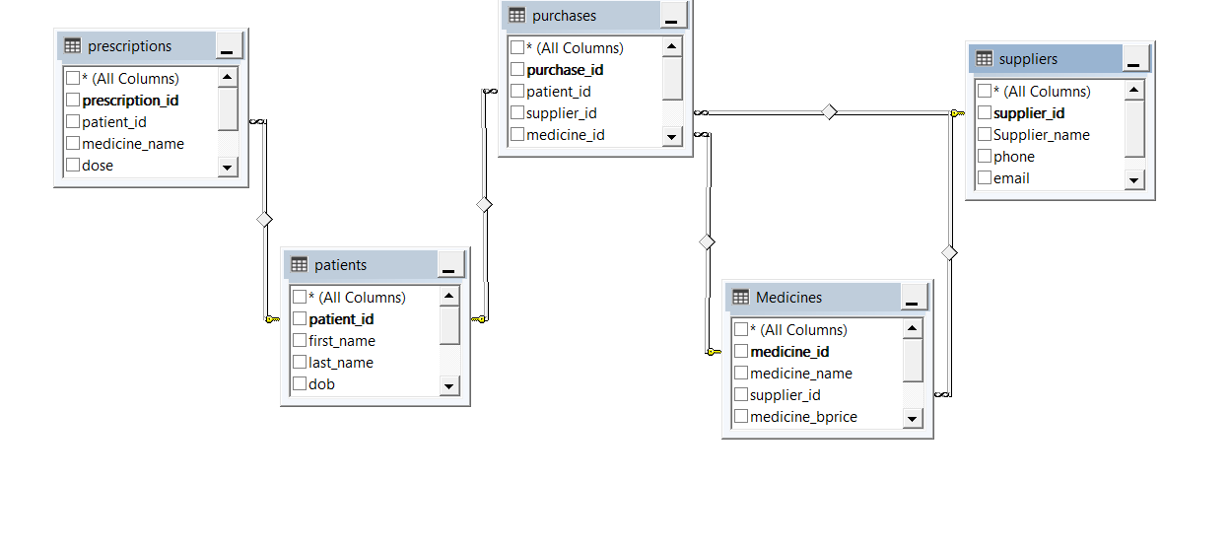

## **5-) SCENARİOS**

1. **Login in as a pharmacist** 
   * 1. Pharmacist should be saved to system.
     2. Then, write Pharmacist information
        1. Pharmacist ID
        2. Pharmacist Password
     3. Login is confirmed
2. **Employee Adding**
   * 1. First, it must be a pharmacist.
     2. Then, using Pharmacist ID and password can log in to system
     3. Go to the Employee form page.
     4. Add new employee information

- EmployeeID

- Employee Name

- Employee Surname

- Phone

- Salary

- Gender

- Starting Date

* + 1. Click Add Button
    2. Adding is confirmed

1. **Employee Deleting**
   * 1. First, it must be a pharmacist.
     2. Then, using Pharmacist ID and password can log in to system
     3. Go to the Employee form page.
     4. Select from ID to find the employee.
     5. Delete employee
     6. Deleting is confirmed
2. **Employee Updating**
   * 1. First, it must be a pharmacist.
     2. Then, using Pharmacist ID and password can log in to system
     3. Go to the Employee form page.
     4. Select from ID to find the employee
     5. Update which information you want to update

- EmployeeID

- Employee Name

- Employee Surname

- Phone

- Salary

- Gender

- Starting Date

* + 1. Updating is confirmed

1. **Medicine Adding**
   * 1. First, it must be a pharmacist.
     2. Then, using Pharmacist ID and password can log in to system
     3. Go to the Medicine Form page.
     4. Add new Medicine information

- MedicineID

- Medicine Name

- Buying Price

- Selling price

- Expire Time

- Supplier

- Quantity

* + 1. Click Add Button
    2. Adding is confirmed

1. **Medicine Deleting**
   * 1. First, it must be a pharmacist.
     2. Then, using Pharmacist ID and password can log in to system
     3. Go to the Medicine Form page.
     4. Select from ID to find the Medicine.
     5. Delete Medicine
     6. Deleting is confirmed
2. **Medicine Updating**
   * 1. First, it must be a pharmacist.
     2. Then, using Pharmacist ID and password can log in to system
     3. Go to the Medicine Form page.
     4. Select from ID to find the Medicine
     5. Update which information you want to update

- MedicineID

- Medicine Name

- Buying Price

- Selling price

- Expire Time

- Supplier

- Quantity

* + 1. Updating is confirmed

1. **Patient Adding**
   * 1. First, it must be a pharmacist.
     2. Then, using Pharmacist ID and password can log in to system
     3. Go to the Patient form page.
     4. Add new Patient information

- Patient ID

- Patient Name

- Patient Surname

- Date Of Birth

- Phone

- Address

- Gender

- Mail

* + 1. Click Add Button
    2. Adding is confirmed

1. **Patient Deleting**
   * 1. First, it must be a pharmacist.
     2. Then, using Pharmacist ID and password can log in to system
     3. Go to the Patient Form page.
     4. Select from ID to find the Patient.
     5. Delete Patient
     6. Deleting is confirmed
2. **Patient Updating**
   * 1. First, it must be a pharmacist.
     2. Then, using Pharmacist ID and password can log in to system
     3. Go to the Patient Form page.
     4. Select from ID to find the Patient
     5. Update which information you want to update

- Patient ID

- Patient Name

- Patient Surname

- Date Of Birth

- Phone

- Address

- Gender

- Mail

* + 1. Updating is confirmed

1. **Prescription Adding**
   * 1. First, it must be a pharmacist.
     2. Then, using Pharmacist ID and password can log in to system
     3. Go to the Prescription form page.
     4. Add new Prescription information

- Prescription ID

- Patient ID

- Medicine Name

- Dose

- Quantity

- Refills

- Date Written

* + 1. Click Add Button
    2. Adding is confirmed

1. **Prescription Deleting**
   * 1. First, it must be a pharmacist.
     2. Then, using Pharmacist ID and password can log in to system
     3. Go to the Prescription Form page.
     4. Select from ID to find the Prescription.
     5. Delete Prescription
     6. Deleting is confirmed
2. **Prescription Updating**
   * 1. First, it must be a pharmacist.
     2. Then, using Pharmacist ID and password can log in to system
     3. Go to the Prescription Form page.
     4. Select from ID to find the Prescription
     5. Update which information you want to update

- Prescription ID

- Patient ID

- Medicine Name

- Dose

- Quantity

- Refills

- Date Written

* + 1. Updating is confirmed

1. **Purchases Adding**
   * 1. First, it must be a pharmacist.
     2. Then, using Pharmacist ID and password can log in to system
     3. Go to the Purchases form page.
     4. Add new Purchases information

- Purchases ID

- Supplier ID

- Medicine ID

- Price

- Quantity

- Date Purchased

* + 1. Click Add Button
    2. Adding is confirmed

1. **Purchases Deleting**
   * 1. First, it must be a pharmacist.
     2. Then, using Pharmacist ID and password can log in to system
     3. Go to the Purchases Form page.
     4. Select from ID to find the Purchases.
     5. Delete Purchases
     6. Deleting is confirmed
2. **Purchases Updating**
   * 1. First, it must be a pharmacist.
     2. Then, using Pharmacist ID and password can log in to system
     3. Go to the Purchases Form page.
     4. Select from ID to find the Purchases
     5. Update which information you want to update

- Purchases ID

- Supplier ID

- Medicine ID

- Price

- Quantity

- Date Purchased

* + 1. Updating is confirmed.

1. **Supplier Adding**
   * 1. First, it must be a pharmacist.
     2. Then, using Pharmacist ID and password can log in to system
     3. Go to the Supplier form page.
     4. Add new Supplier information

- Supplier ID

- Supplier Name

- Phone number

- Address

- Mail

* + 1. Click Add Button
    2. Adding is confirmed

1. **Supplier Deleting**
   * 1. First, it must be a pharmacist.
     2. Then, using Pharmacist ID and password can log in to system
     3. Go to the Supplier Form page.
     4. Select from ID to find the Supplier.
     5. Delete Supplier
     6. Deleting is confirmed
2. **Supplier Updating**
   * 1. First, it must be a pharmacist.
     2. Then, using Pharmacist ID and password can log in to system
     3. Go to the Supplier Form page.
     4. Select from ID to find the Supplier
     5. Update which information you want to update

- Supplier ID

- Supplier Name

- Phone number

- Address

- Mail

* + 1. Updating is confirmed.

1. **Showing Report 1** 
   * 1. First, it must be a pharmacist.
     2. Then, using Pharmacist ID and password can log in to system
     3. Go to the Reports Form page.
     4. Select Medicines By Product
     5. Process completed
2. **Showing Report 2** 
   * 1. First, it must be a pharmacist.
     2. Then, using Pharmacist ID and password can log in to system
     3. Go to the Reports Form page.
     4. Select Prescription reports.
     5. Process completed.
3. **Login in as a Admin** 
   * 1. Admin should be saved to system.
     2. Then, write Admin information
        1. Pharmacist ID
        2. Pharmacist
        3. Login is confirmed.
4. **User Adding**
   * 1. First, it must be a Admin.
     2. Then, using Admin ID and password can log in to system
     3. Go to the User form page.
     4. Add new User information

- User ID

- First Name

- Last Name

- E mail

- Password

* + 1. Click Add Button
    2. Adding is confirmed

1. **User Deleting**
   * 1. First, it must be a Admin.
     2. Then, using Admin ID and password can log in to system
     3. Go to the User Form page.
     4. Select from ID to find the User.
     5. Delete User
     6. Deleting is confirmed
2. **User Updating**
   * 1. First, it must be a Admin.
     2. Then, using Admin ID and password can log in to system
     3. Go to the User Form page.
     4. Select from ID to find the User
     5. Update which information you want to update

- User ID

- First Name

- Last Name

- E mail

- Password

* + 1. Updating is confirmed.

## **7-) USE CASE DIAGRAM**

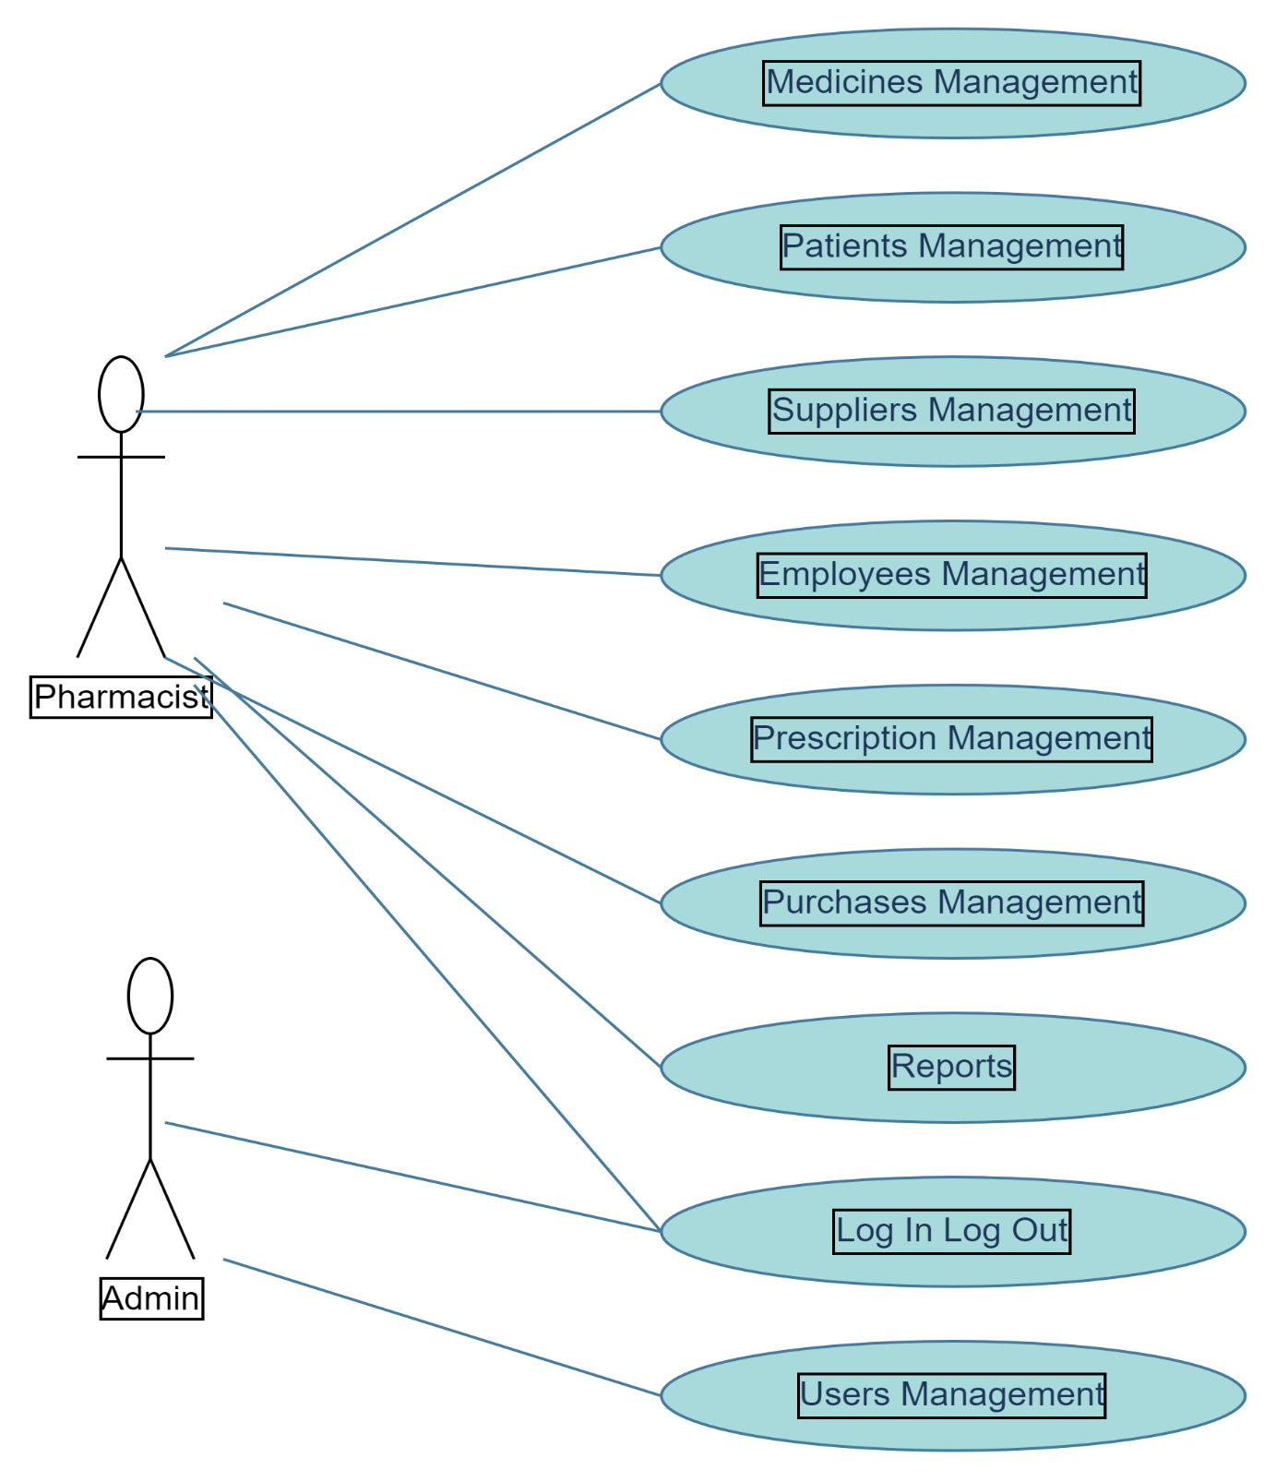

## **8-) SEQUENCE DIAGRAMS**

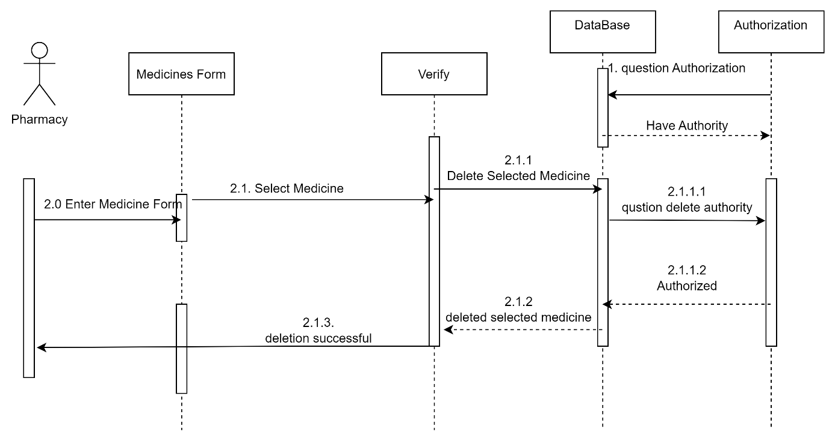

Delete Medicines diagram

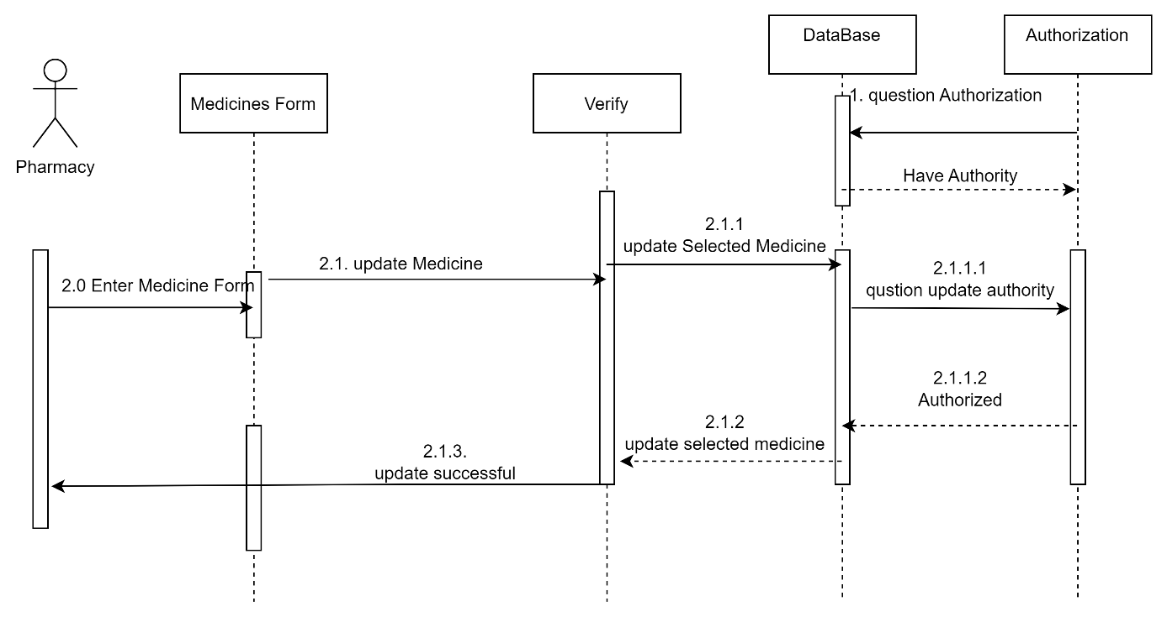

Update Medicines diagram

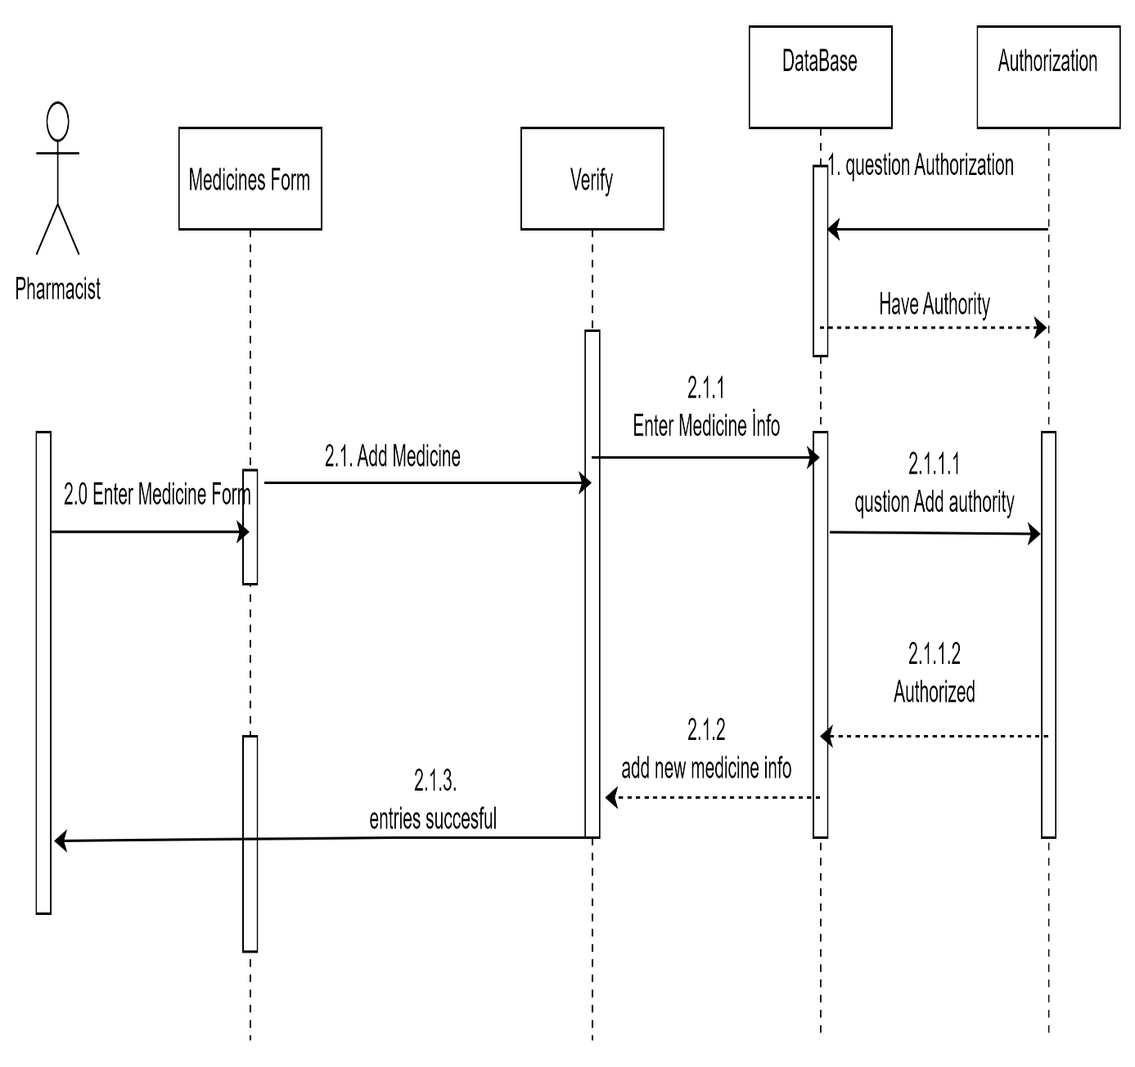

Add Medicines diagram

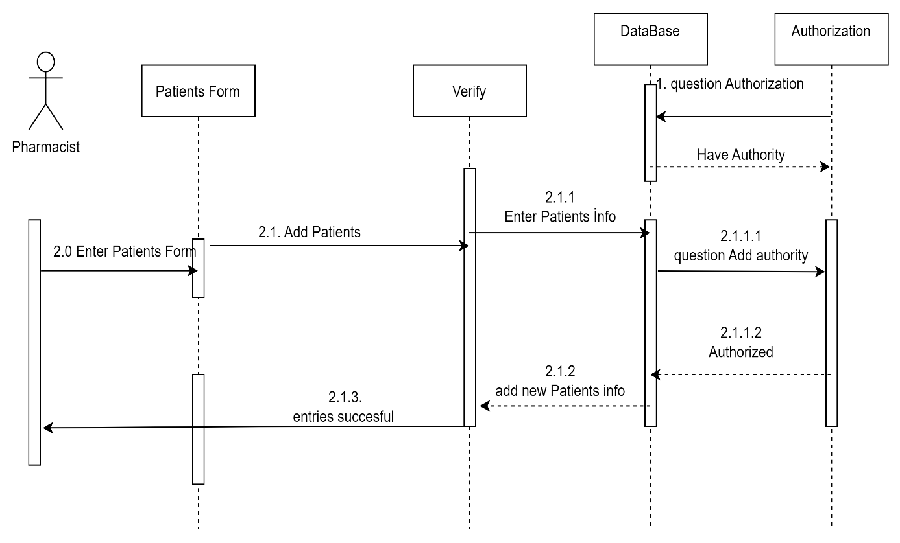

Add Patients diagram

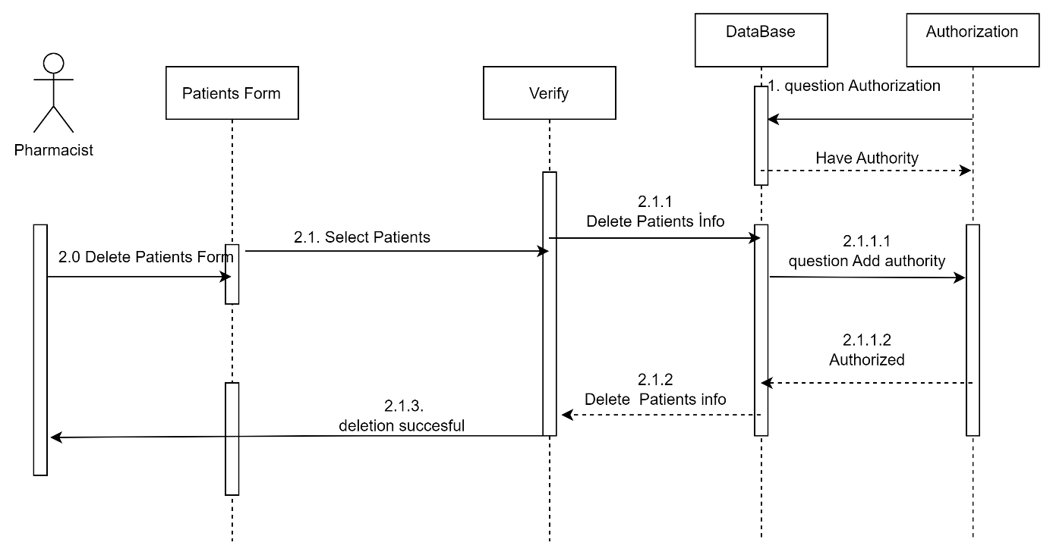

delete Patient’s diagram

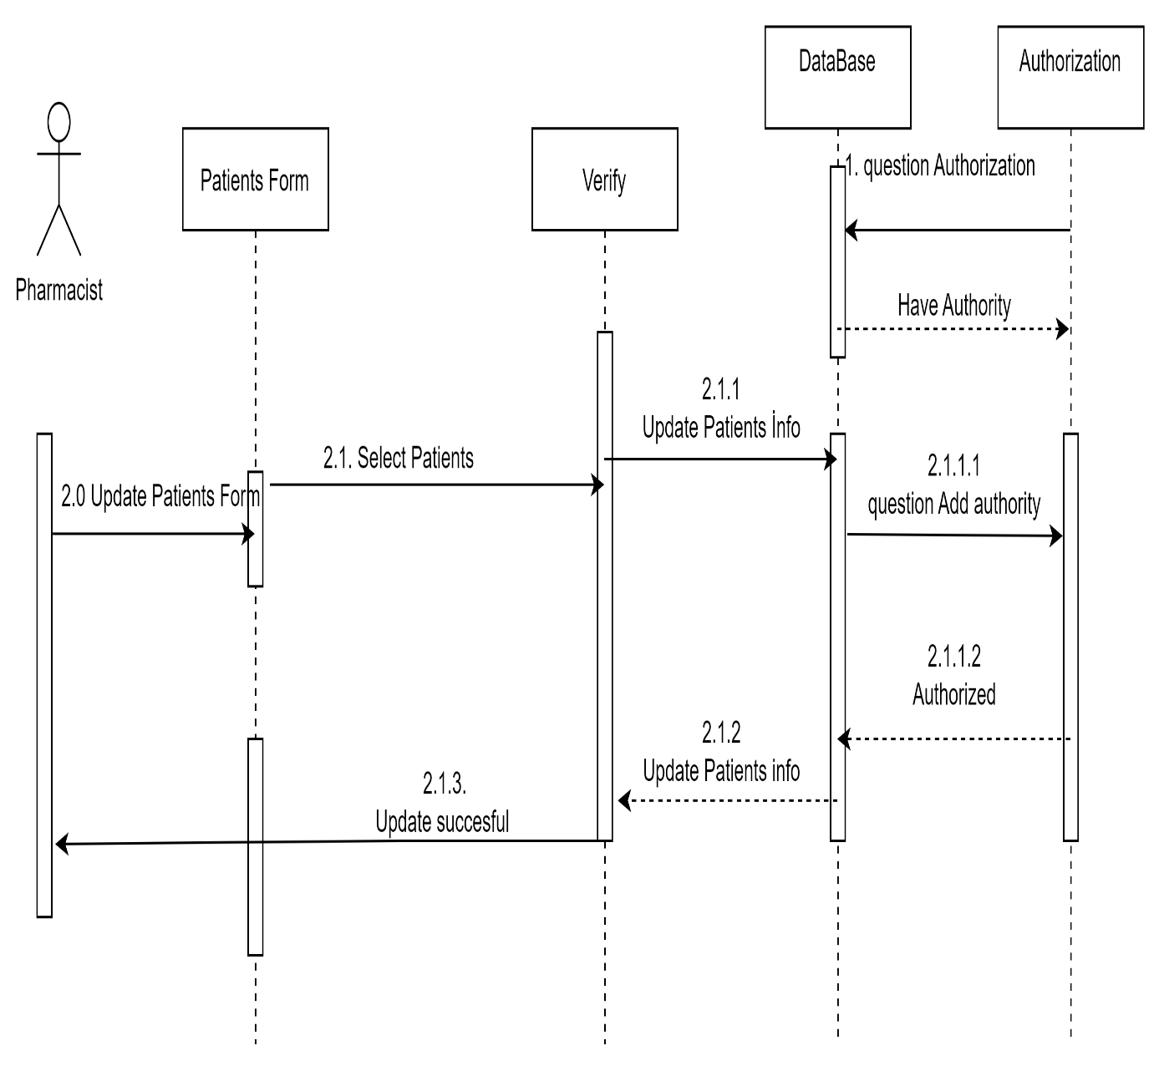

Update Patients diagram

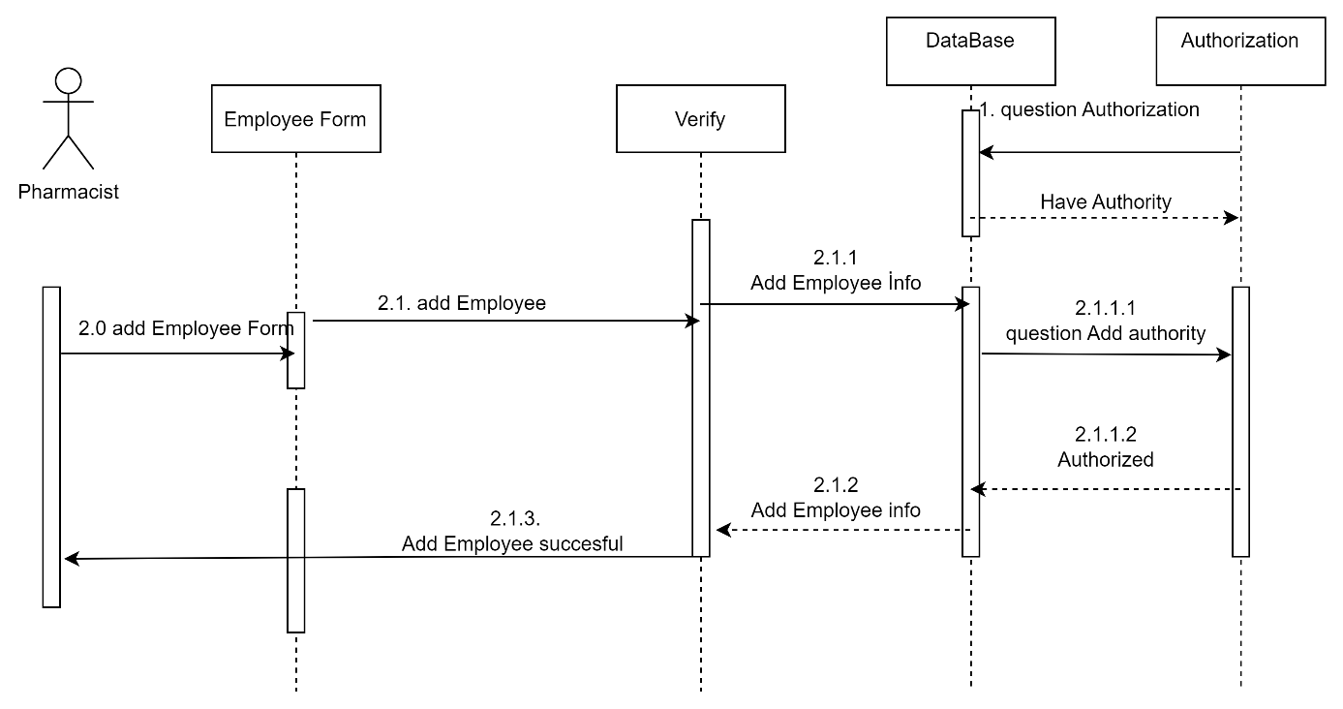

Add Employee diagram

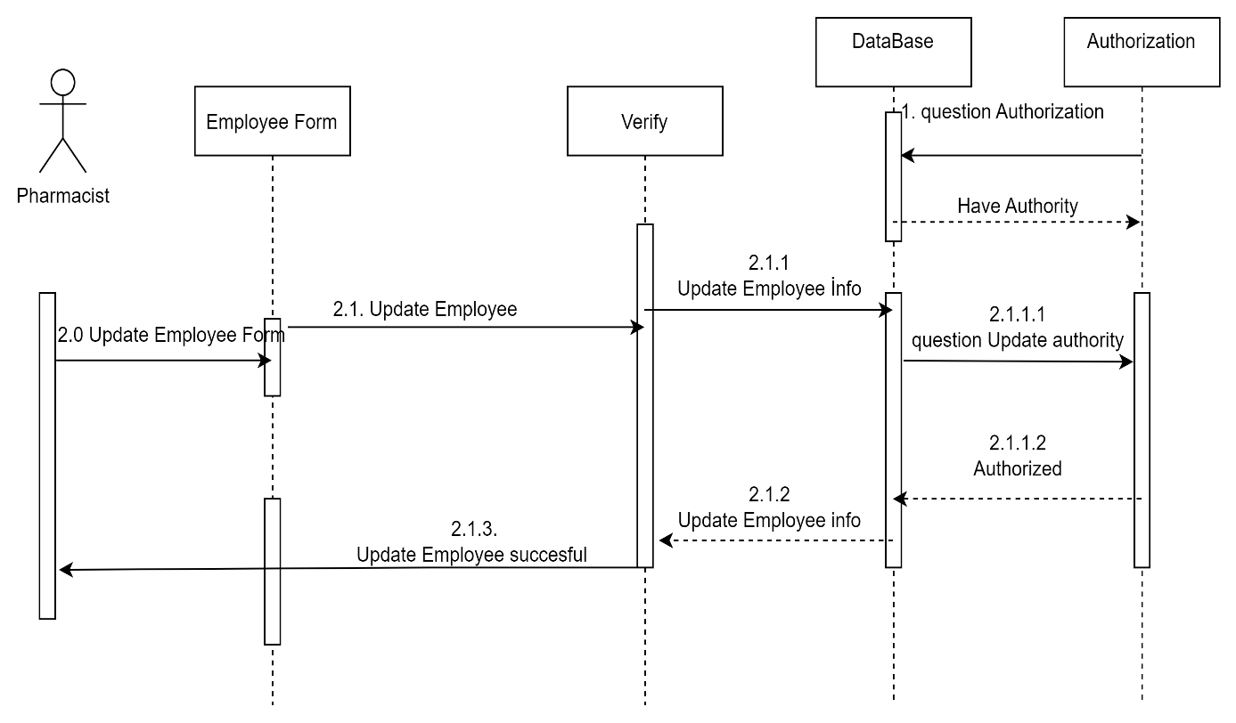

Update Employee diagram

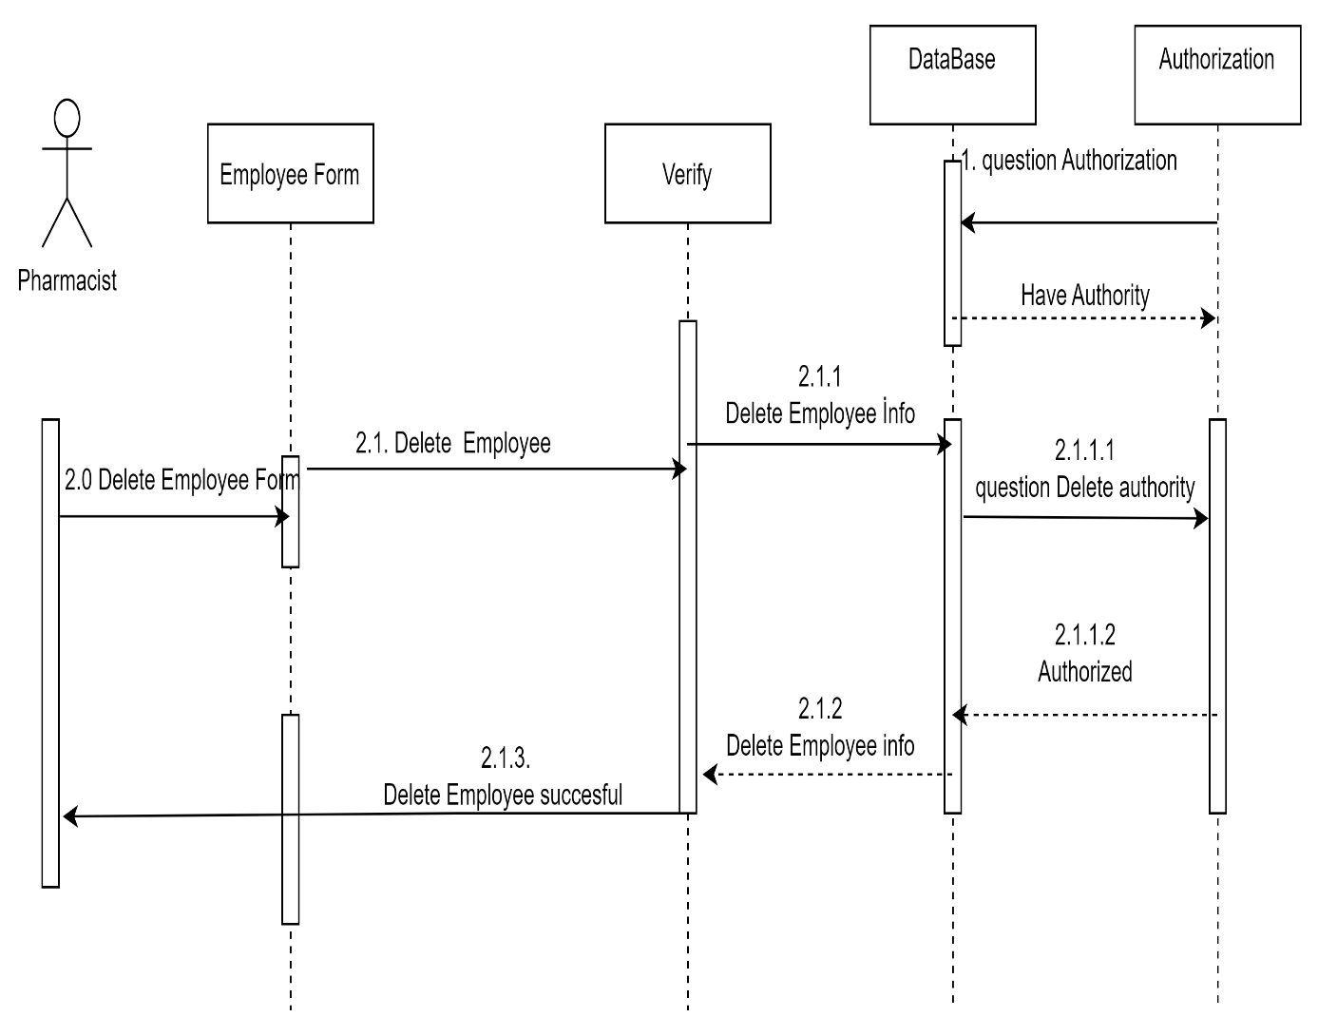

Delete Employee diagram

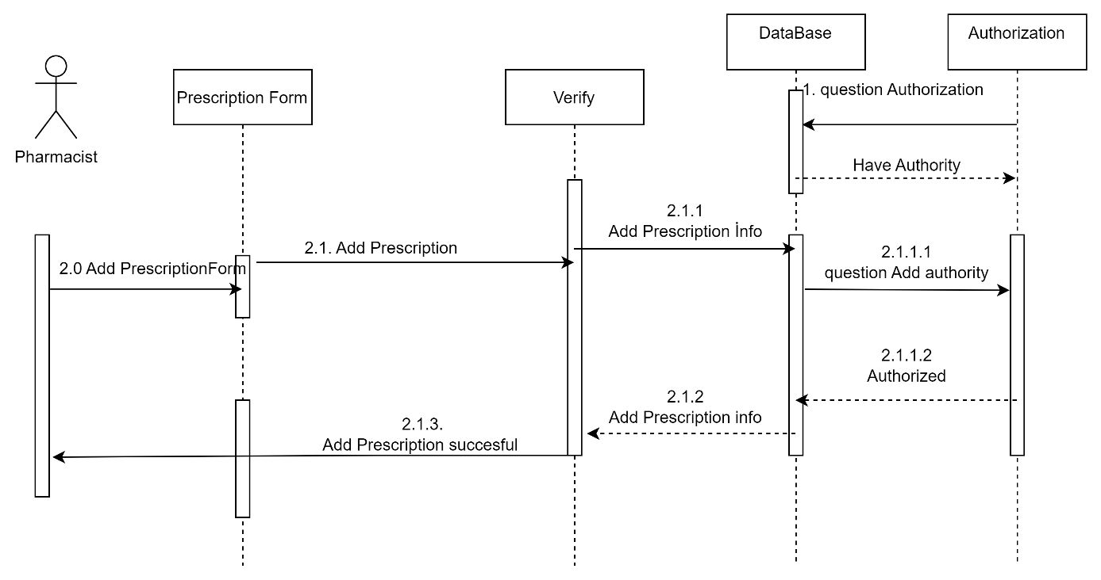

Add prescription diagram

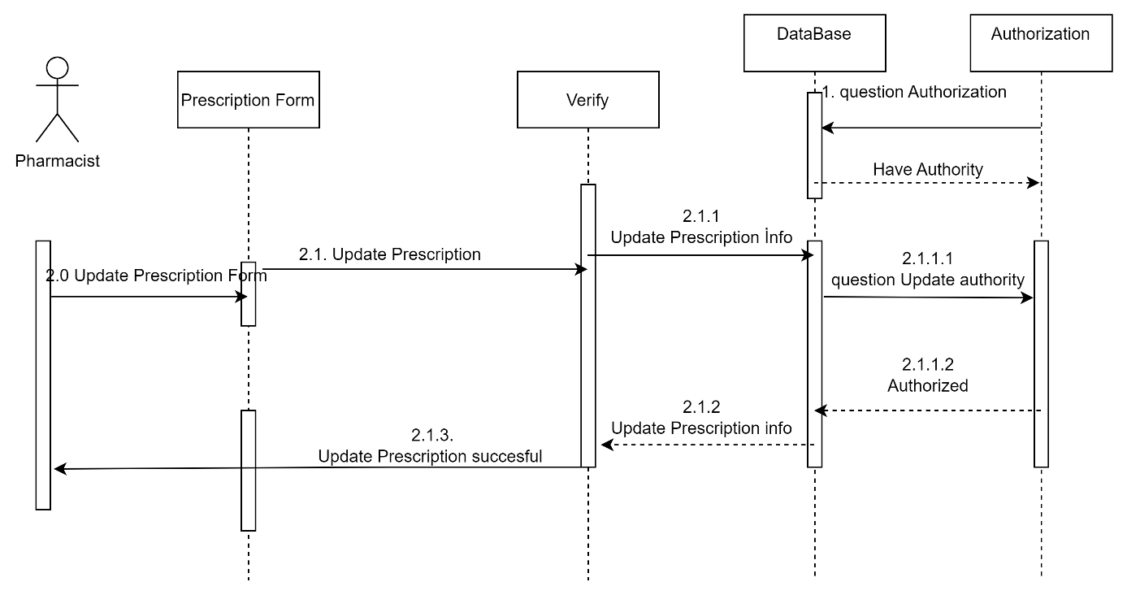

Update prescription diagram

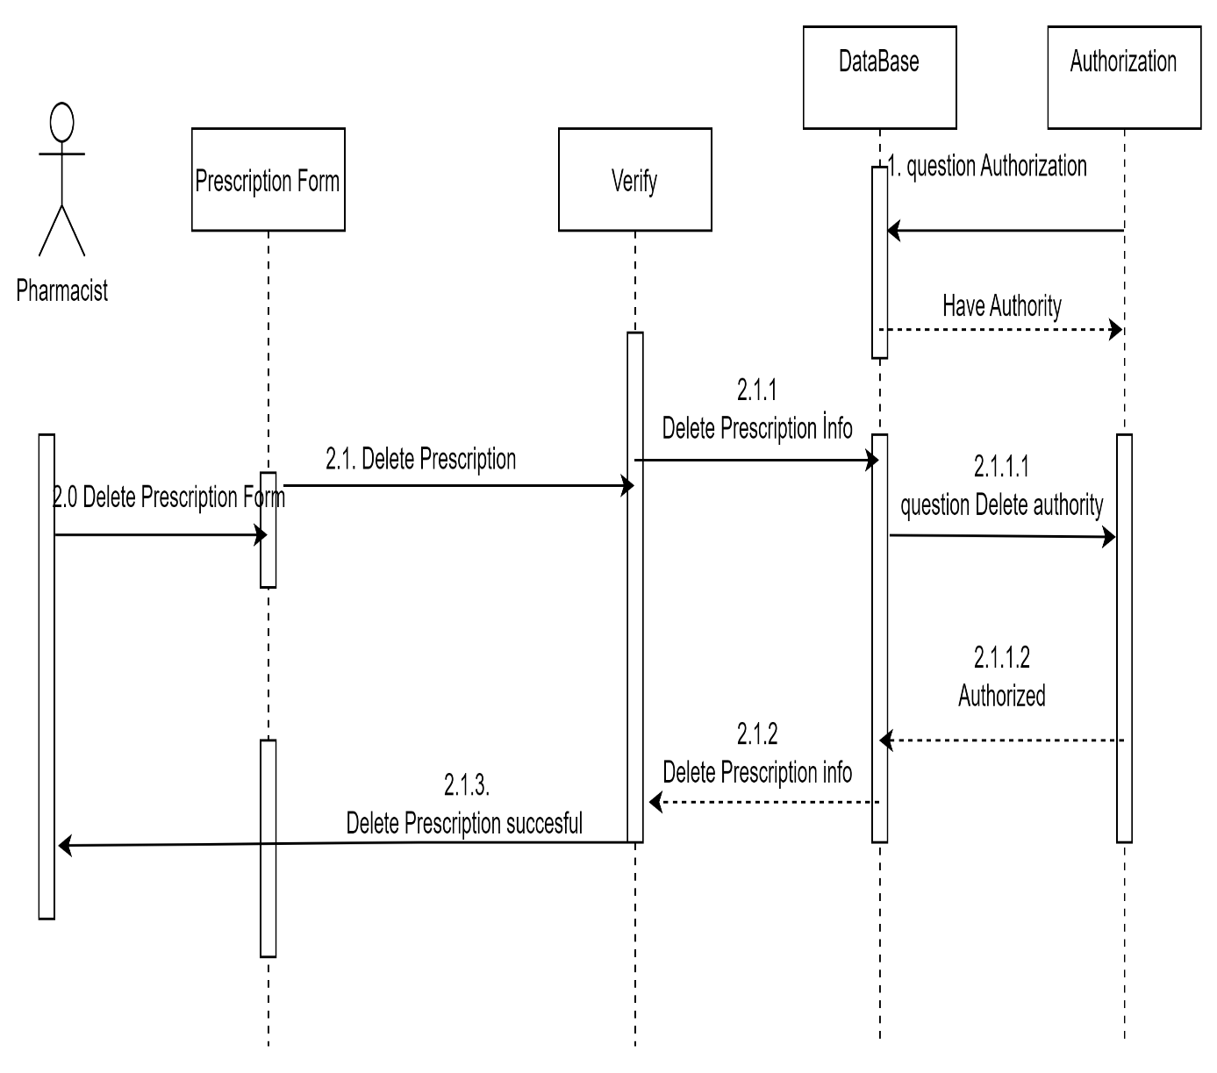

Delete prescription diagram

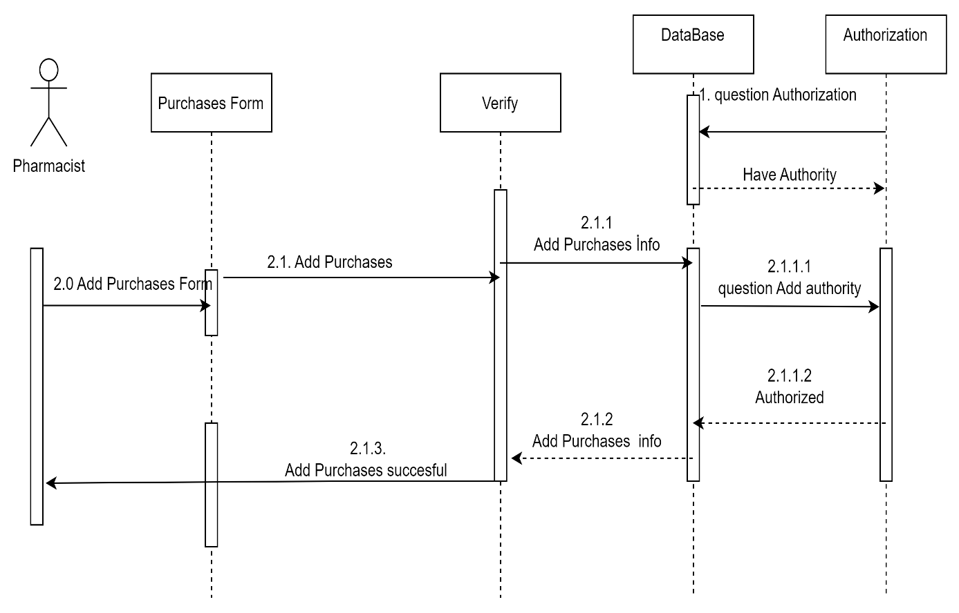

Add purchases diagram

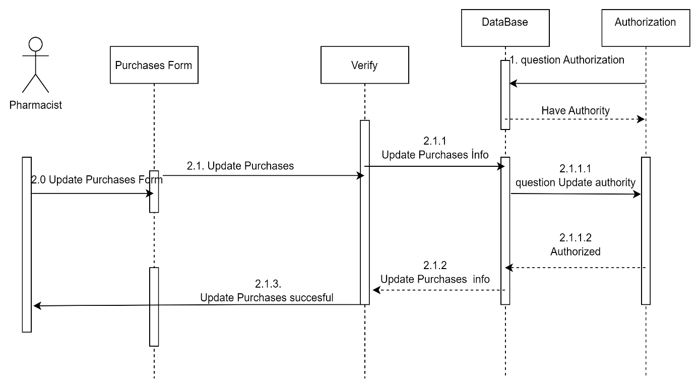

Update purchases diagram

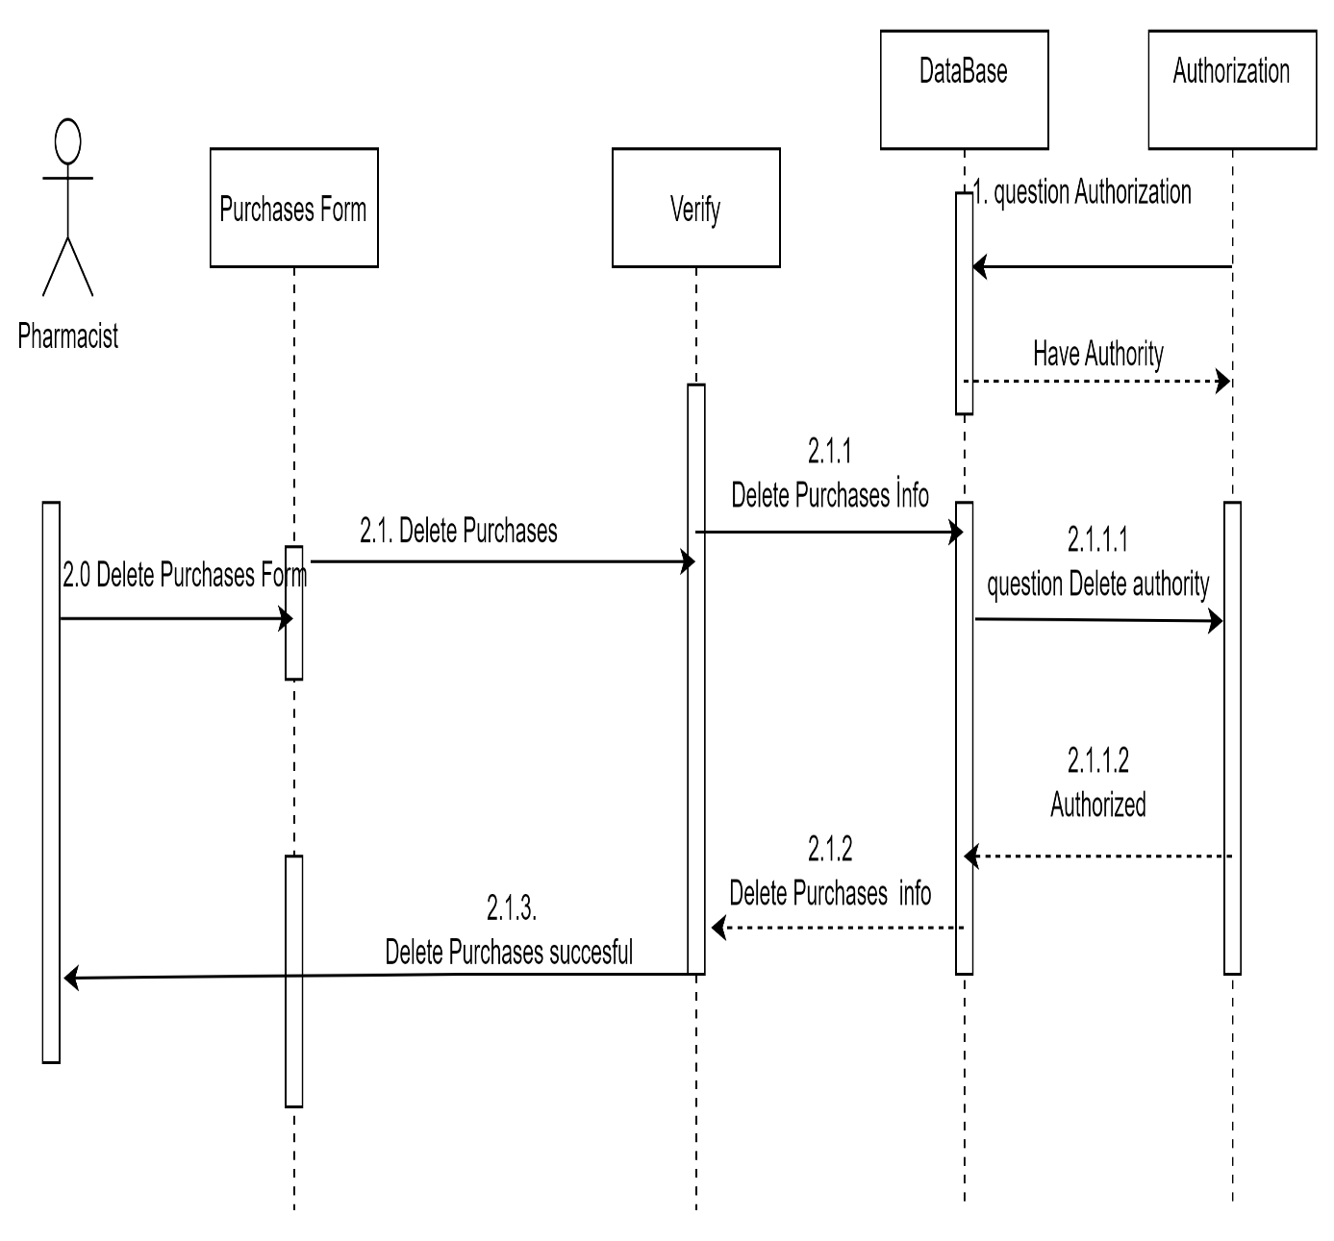

Delete purchases diagram

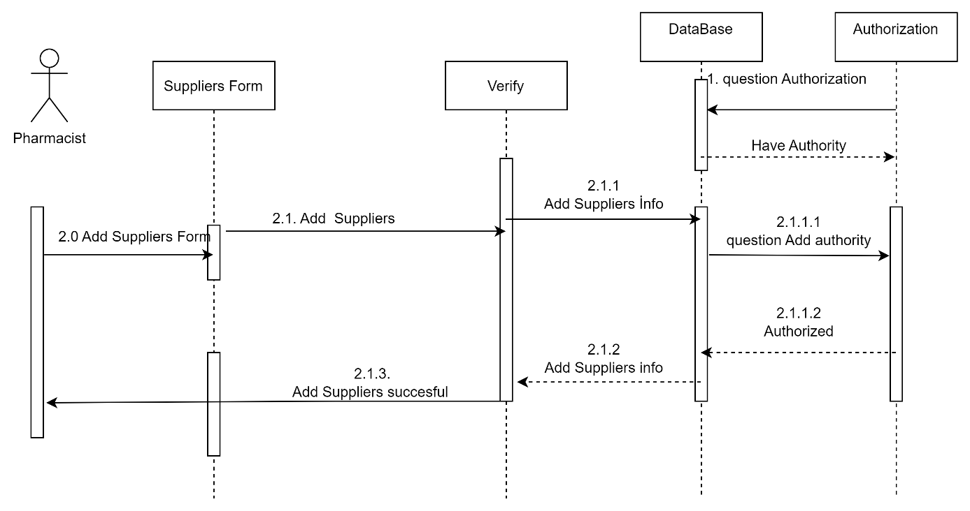

Add Suppliers diagram

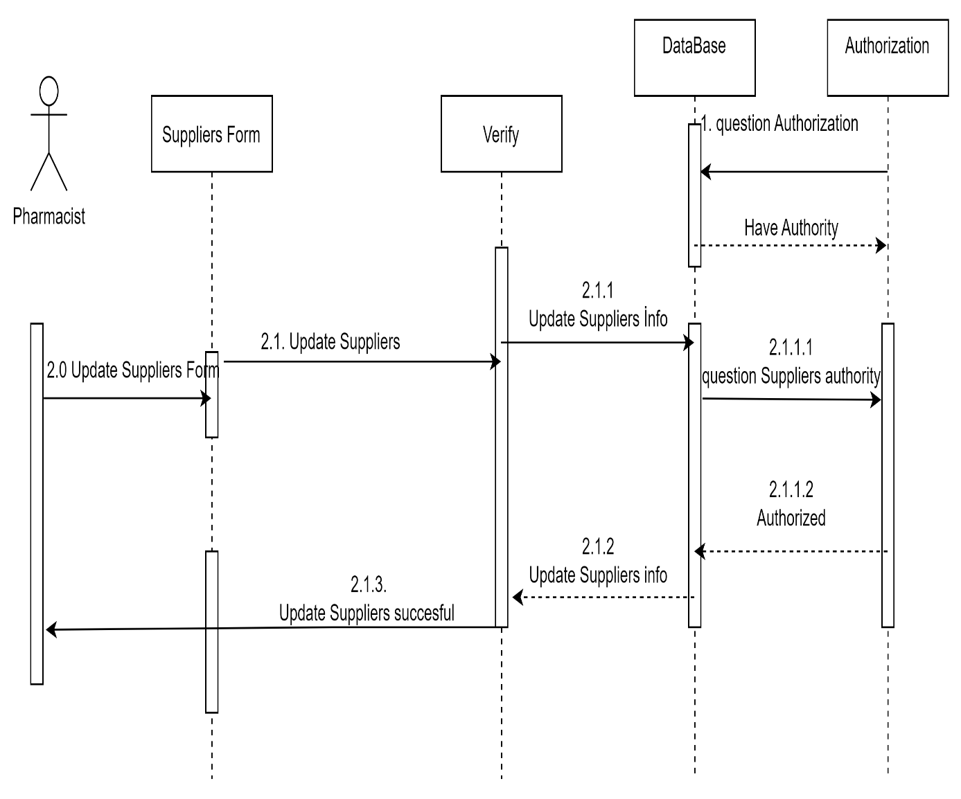

Update Suppliers diagram

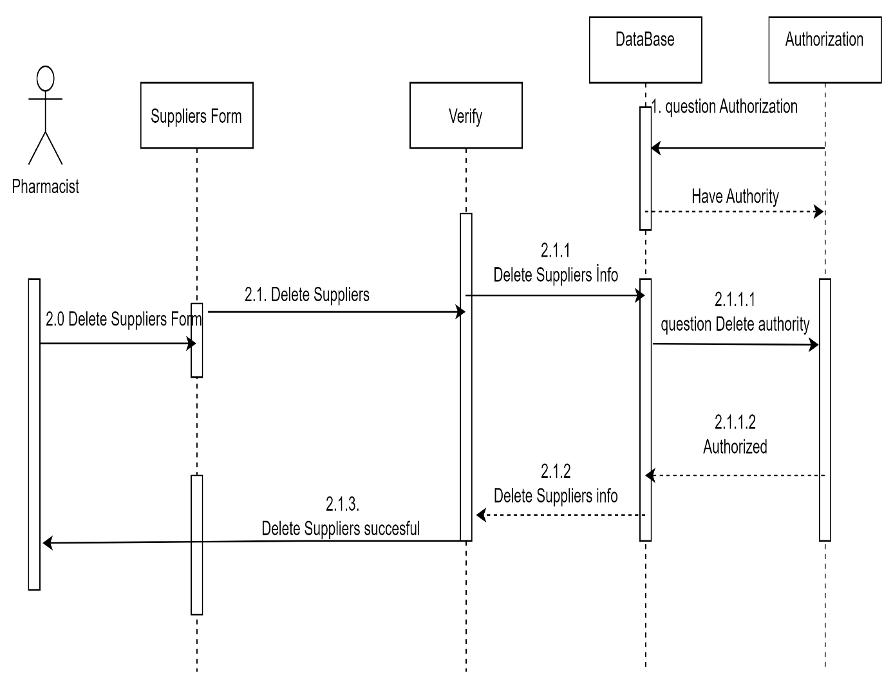

Delete Suppliers diagram

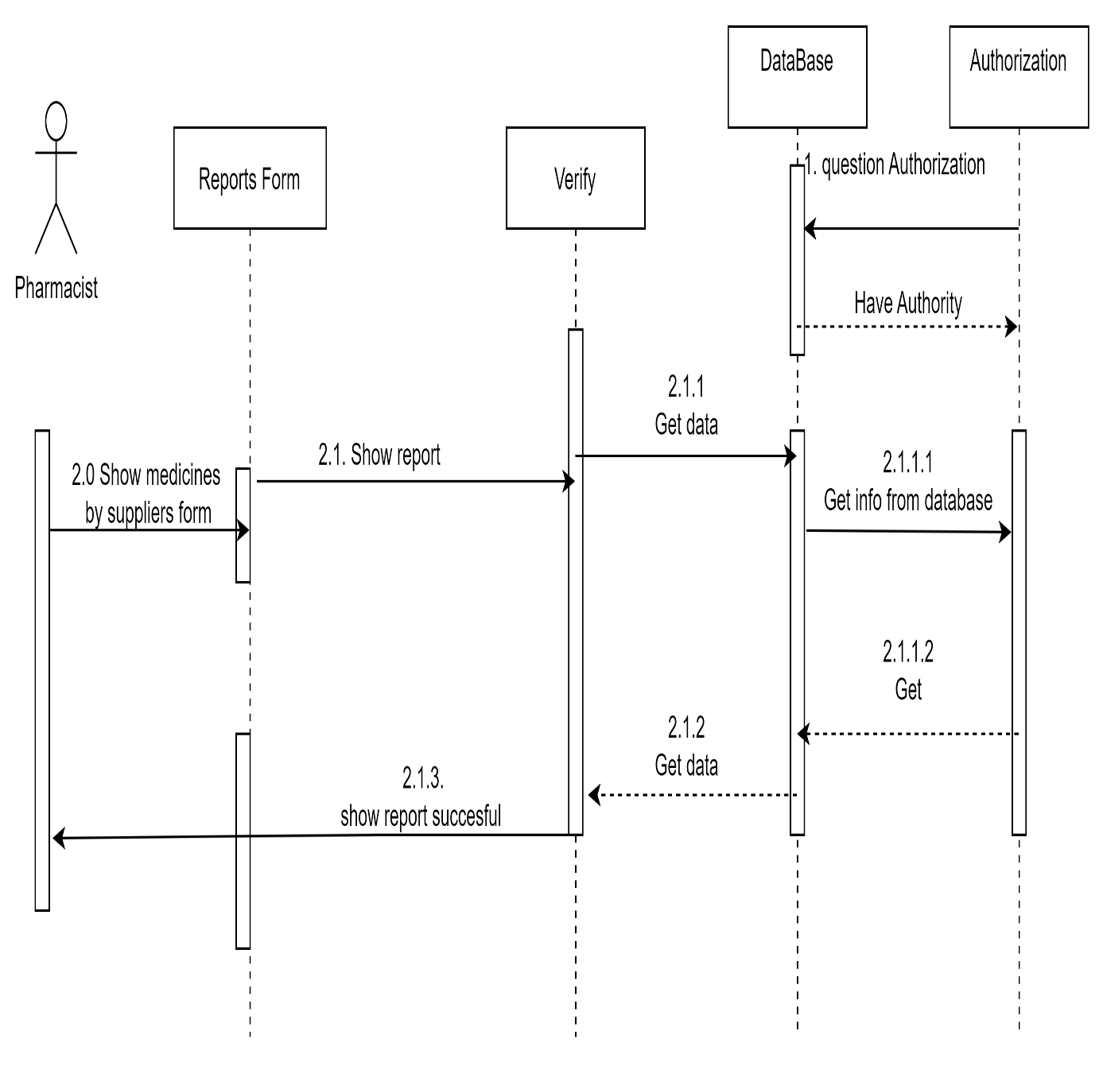

Medicines by suppliers’ report diagram

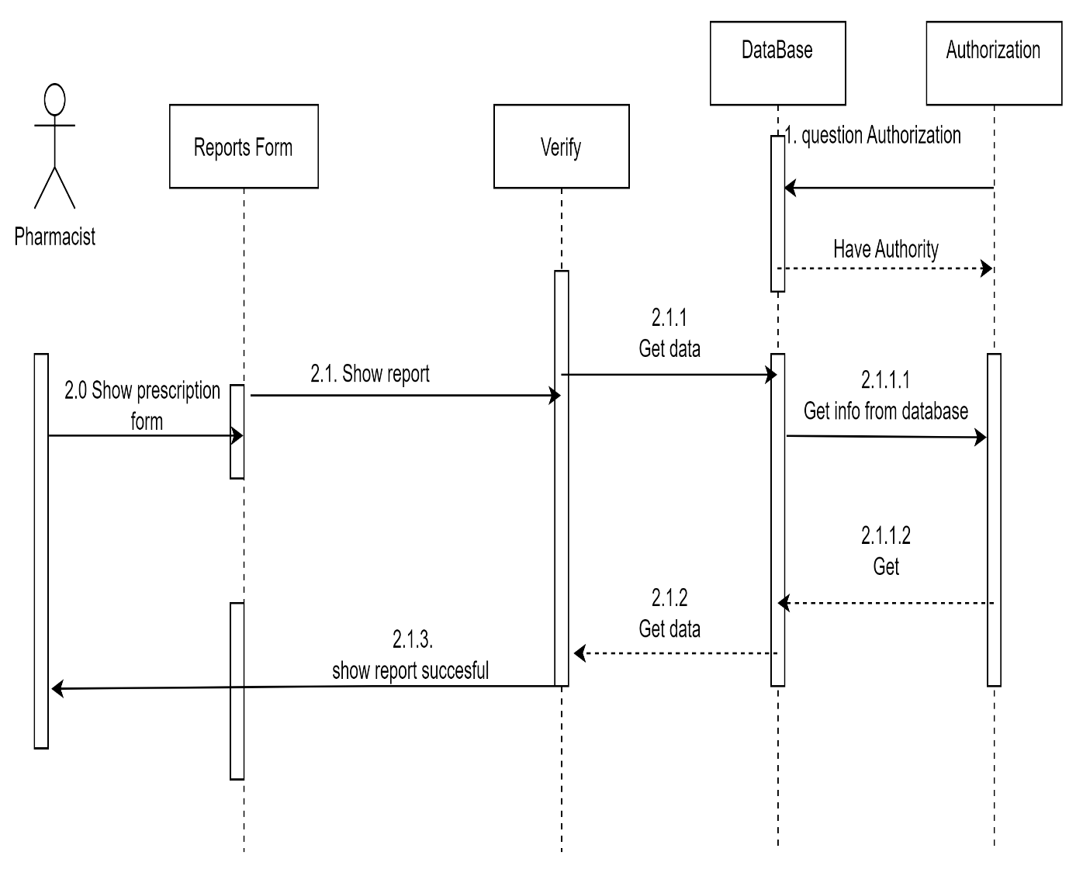

prescriptions report diagram

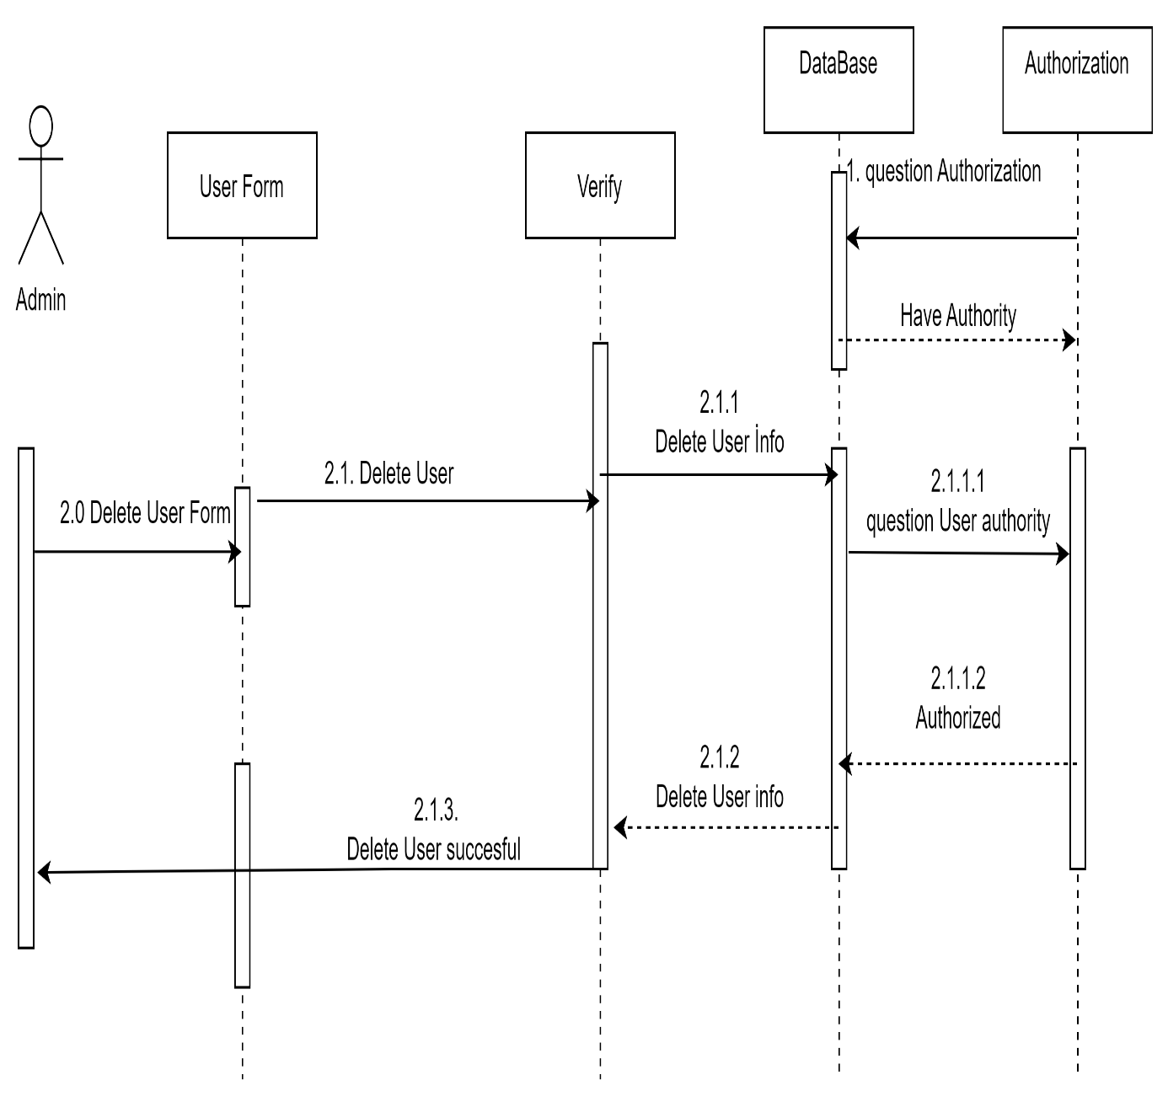

Users Delete diagram

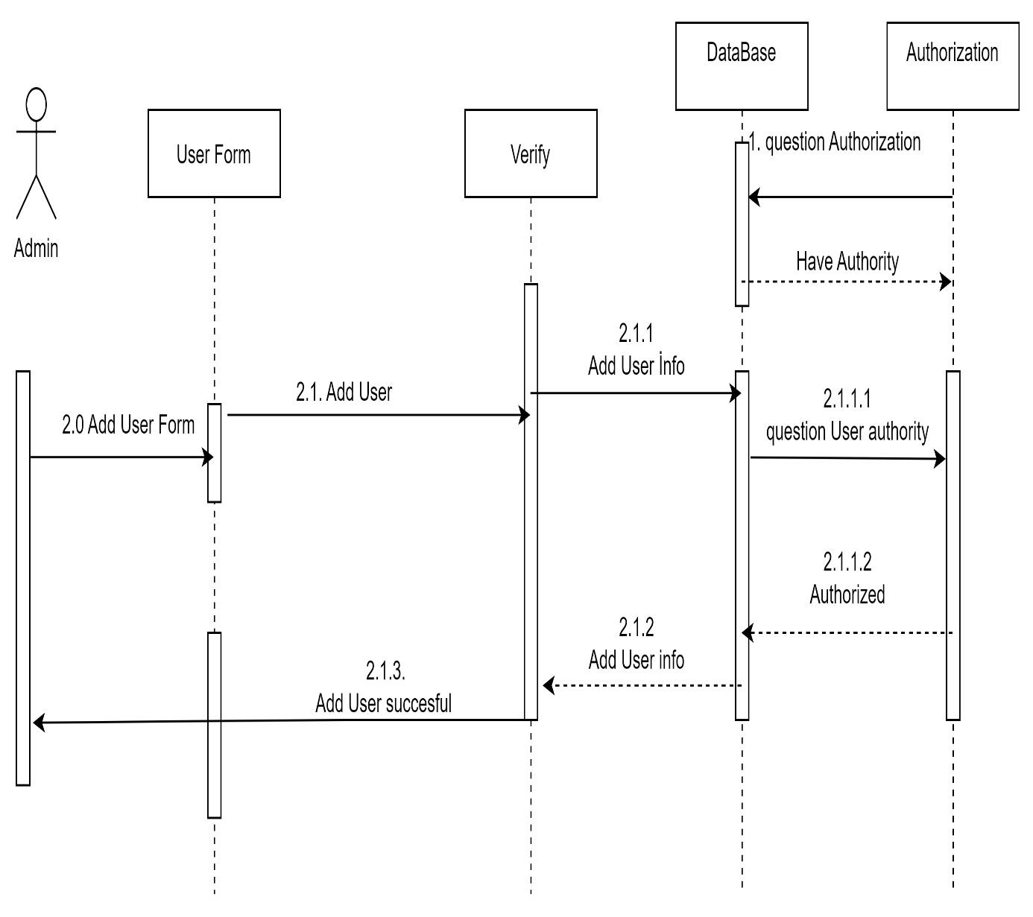

Users Add diagram

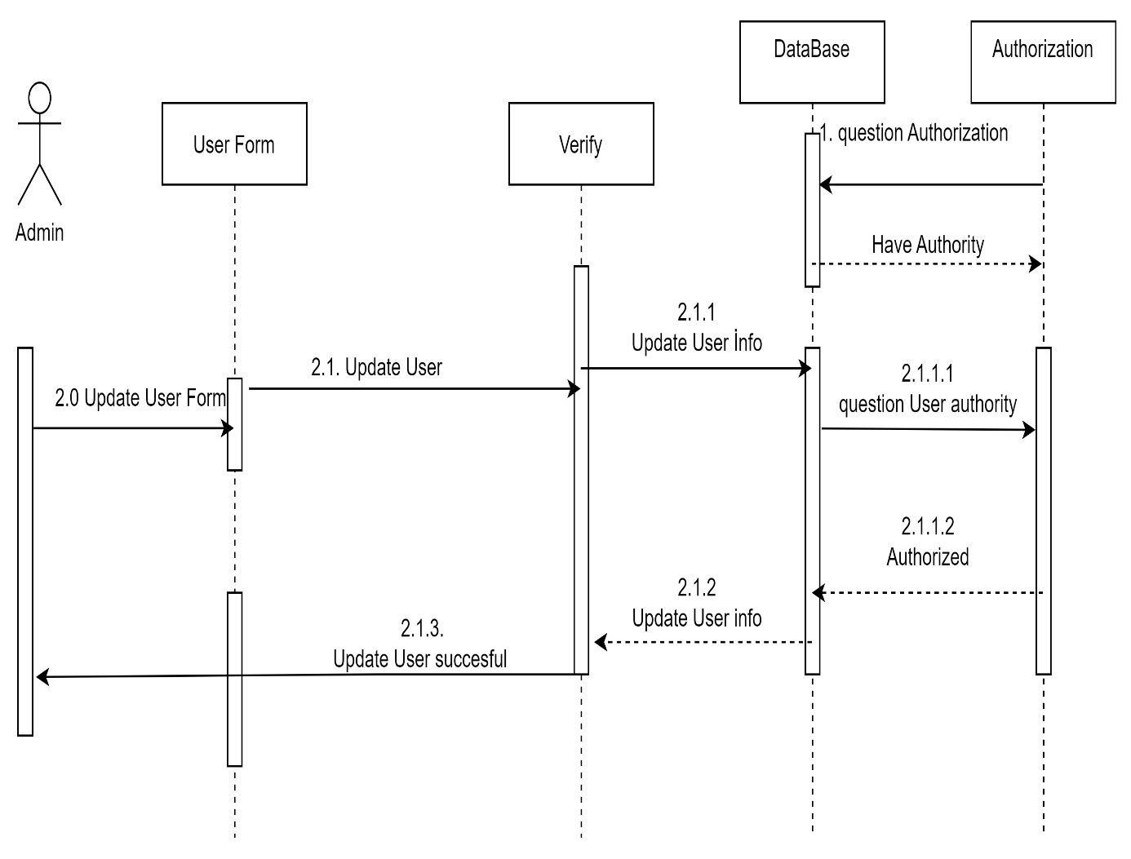

Users Update diagram

## 

## **9-) TECHNOLOGIES USED AND THEIR DEFINITIONS**

1. **C#:**
   1. C# is the next generation programming language developed by Microsoft. It is one of the languages developed for .NET Technology, also developed by Microsoft.
2. **.net Framework:**
   1. .NET is a framework created by Microsoft that allows developers to build a wide range of applications, including desktop, web, and mobile applications, using languages such as C# and Visual Basic. It provides a large library of pre-built code and tools for common tasks, making it easier for developers to create high-quality, reliable applications. Additionally, .NET also includes an execution environment called the Common Language Runtime (CLR), which provides services such as memory management, type safety, and security.
3. **ORM:**
   1. . Object-Relational Mapping (ORM) is a technique for converting data between a relational database and an object-oriented programming language. he main idea behind ORM is to create a mapping between the database schema (tables, columns, etc.) and the classes and objects in the application. This allows developers to work with databases using a more familiar object-oriented paradigm, rather than writing low-level SQL statements.
4. **Entity Framework:**
   1. Entity Framework is an ORM and ORMs are intended to increase developer productivity by reducing the unnecessary tasks of persisting data used in applications.
5. **Microsoft Reporting Services:**
   1. Microsoft Reporting Services for .Net windows form application. Contains the assemblies required to use the Windows Form Report Viewer Control.

## **10-) DESIGN PATTERNS TO BE USED IN THE PROJECT**

1. **Repository design pattern**
   1. It is a design pattern that enables data access and management to be reduced to a single point in data-centric applications
2. \***Builder design pattern**:
3. **Singleton design pattern**:
   1. A pattern that prevents the re-establishment of a class instance written in object-oriented programming and the creation of a different class instance each time is called
4. **Layered architecture** 
   1. layered architecture is a design pattern that helps to separate the different concerns of an application and make it more maintainable, testable, and scalable.

Görkem Özyurt

218MI1034